

**Industrial Training**

**At**



**Solapur.**

From 07th June 2023 to 22nd July 2023

**Name of Supervisor:** Karale Dhiraj.

**Designation of Supervisor:** CEO, DK Techno’s Solapur.

**Names of Students:**

* Dharashivkar Aditya.
* Kaustubh Makude.
* Abhishek Maske
* Shreyash Sawalgi
* Tanmay Kulkarni

**Branch of Engineering:** Information Technology.

**Name of Polytechnic:** Government Polytechnic Solapur.



**CERTIFICATE**

**MAHARASHTRA STATE BOARD OF TECHNICAL EDUCATION MUMBAI**

**GOVERNMENT POLYTECHNIC, SOLAPUR**

This is to certify ***Mr. Dharashivkar Aditya Mahesh.* Roll No:*20* of** Fifth Semester of Diploma in Information Technology of Institute ***Government Polytechnic, Solapur (Code:******0015)*** have complete the Training & Project work satisfactorily under my supervision and Mentorship in Industrial Training ***ITR (22057)*** for the academic year ***2023-2024*** as prescribed in the curriculum.

**Mrs. Anjikhane M Mrs. Anjikhane M**

*(Training Mentor)*  *( H.O.D. )*



**CERTIFICATE**

**MAHARASHTRA STATE BOARD OF TECHNICAL EDUCATION MUMBAI**

**GOVERNMENT POLYTECHNIC, SOLAPUR**

This is to certify ***Mr. Maske Abhishek Sunil.* Roll No:*58* of** Fifth Semester of Diploma in Information Technology of Institute ***Government Polytechnic, Solapur (Code:******0015)*** have complete the Training & Project work satisfactorily under my supervision and Mentorship in Industrial Training ***ITR (22057)*** for the academic year ***2023-2024*** as prescribed in the curriculum.

**Mrs. Kumbhar Mam Mrs. Anjikhane M**

*(Training Mentor)*  *( H.O.D. )*



**CERTIFICATE**

**MAHARASHTRA STATE BOARD OF TECHNICAL EDUCATION MUMBAI**

**GOVERNMENT POLYTECHNIC, SOLAPUR**

This is to certify ***Mr. Kaustubh Makude Ishvar.* Roll No:*53* of** Fifth Semester of Diploma in Information Technology of Institute ***Government Polytechnic, Solapur (Code:******0015)*** have complete the Training & Project work satisfactorily under my supervision and Mentorship in Industrial Training ***ITR (22057)*** for the academic year ***2023-2024*** as prescribed in the curriculum.

**Mrs. Kumbhar Mam Mrs. Anjikhane M**

*(Training Mentor)*  *( H.O.D. )*



**CERTIFICATE**

**MAHARASHTRA STATE BOARD OF TECHNICAL EDUCATION MUMBAI**

**GOVERNMENT POLYTECHNIC, SOLAPUR**

This is to certify ***Mr. Kulkarni Tanmay Santosh.* Roll No:*49* of** Fifth Semester of Diploma in Information Technology of Institute ***Government Polytechnic, Solapur (Code:******0015)*** have complete the Training & Project work satisfactorily under my supervision and Mentorship in Industrial Training ***ITR (22057)*** for the academic year ***2023-2024*** as prescribed in the curriculum.

**Mrs. Kumbhar Mam Mrs. Anjikhane M**

*(Training Mentor)*  *( H.O.D. )*



**CERTIFICATE**

**MAHARASHTRA STATE BOARD OF TECHNICAL EDUCATION MUMBAI**

**GOVERNMENT POLYTECHNIC, SOLAPUR**

This is to certify ***Mr. Sawalgi Shreyash Balasaheb.* Roll No:*32* of** Fifth Semester of Diploma in Information Technology of Institute ***Government Polytechnic, Solapur (Code:******0015)*** have complete the Training & Project work satisfactorily under my supervision and Mentorship in Industrial Training ***ITR (22057)*** for the academic year ***2023-2024*** as prescribed in the curriculum.

**Mrs. Anjikhane M Mrs. Anjikhane M**

*(Training Mentor)*  *( H.O.D. )*

**Abstract**

I completed 6 Weeks of Industrial Training at DK Techno’s one of growing name in software Industry. Where I studied about the Industry organization structure of DK Techno’s, Marketing Strategies of DK Techno’s, Labs & Systems available in company. Technologies used by DK Techno’s to develop their products and provide services which are JAVA, PHP, PYTHON, HTML, CSS, JS, Bootstrap. I also got to know the Development process of industry. Security measures followed while developing software, Testing & Quality assurance methods followed by DK Techno’s.

In the 5th week of the training I had worked on a project by following software industry ethics & practices which I got during this training by DK Techno’s.

The project is *“Study Material Application”* which provides various PDFs, links, and various materials which are useful for Diploma Information Technology students and afterward we would be working on updating the contents in the application to provide study material not only just for IT student but also for all the Diploma students.

**Keywords:**

(Training, Industry, Company, Organization, LAB, Systems, Structure, Software, Domain, Technologies, Development, Security, Testing.)

**Acknowledgement**

The internship opportunity I had with DK Techno’s was a great chance for learning and professional development. Therefore, I consider myself as a very lucky individual as I was provided with an opportunity to be a part of it. I am also grateful for having a chance to meet so many wonderful people and professionals who led me though this internship period.

Bearing in mind previous I am using this opportunity to express my deepest gratitude and special thanks to the MD of DK Techno’s who in spite of being extraordinarily busy with his duties, took time out to hear, guide and keep me on the correct path and allowing me to carry out my project at their esteemed organization and extending during the training.

I express my deepest thanks to ***Mr. Karale Dhiraj*** [CEO,Founder] for taking part in useful decision & giving necessary advices and guidance and arranged all facilities to make life easier. I choose this moment to acknowledge his contribution gratefully.

It is my radiant sentiment to place on record my best regards, deepest sense of gratitude to ***Mrs.* *Anjikhane M.*** [Mentor for Training] for their careful and precious guidance which were extremely valuable for my study both theoretically and practically.

I perceive as this opportunity as a big milestone in my career development. I will strive to use gained skills and knowledge in the best possible way, and I will continue to work on their improvement, in order to attain desired career objectives. Hope to continue cooperation with all of you in the future,

Sincerely,

Dharashivkar Aditya.

**Contents**

|  |  |  |
| --- | --- | --- |
| ***Sr. No.*** | ***Chapter*** | ***Page N0.*** |
| 1 | Industry working Domain | 01 |
| 2 | Know about DK Techno’s | 02 |
| 3 | Organization Structure | 03 |
| 4 | Laboratories | 04 |
| 5 | Core techs for software | 05 |
| 6 | Software Development | 06 |
| 7 | Security practices | 07 |
| 8 | Testing & Quality assurance | 08 |
| 9 | Customer lobby | 09 |
| 10 | My 45 days | 10 |
| 11 | Project:  1.0 Rationale  2.0 Aims/Benefits of the Project  3.0 CO’s Achieved  4.0 Literature Review  5.0 Actual Methodology followed  6.0 Actual Resources used  7.0 Skill Developed/LO’s of Project  8.0 Outputs of project | 11 |
| 12 | References | 12 |



**Training Report**

**ITR (22057)**

**Industrial Training 2023-24**

**At**



**#1**

**Industry Working Domain.**

**The software industry** includes businesses for development, maintenance and publication of software that are using different business models, mainly either "license/maintenance based" (on-premises) or "Cloud based" (such as SaaS, PaaS, IaaS, MBaaS, MSaaS, DCaaS etc.). The industry also includes software services, such as training, documentation, consulting and data recovery.

**History**

The first company founded to provide software products and services was Computer Usage Company in 1955. Before that time, computers were programmed either by customers, or the few commercial computer vendors of the time, such as Sperry Rand and IBM.

The software industry expanded in the early 1960s, almost immediately after computers were first sold in mass-produced quantities. Universities, government, and business customers created a demand for software. Many of these programs were written in-house by full-time staff programmers. Some were distributed freely between users of a particular machine for no charge. Others were done on a commercial basis, and other firms such as Computer Sciences Corporation (founded in 1959) started to grow. Other influential or typical software companies begun in the early 1960s included Advanced Computer Techniques, Automatic Data Processing, Applied Data Research, and Informatics General. The computer/hardware makers started bundling operating systems, systems software and programming environments with their machines.

When Digital Equipment Corporation (DEC) brought a relatively low-priced microcomputer to market, it brought computing within the reach of many more companies and universities worldwide, and it spawned great innovation in terms of new, powerful programming languages and methodologies. New software was built for microcomputers, so other manufacturers including IBM, followed DEC's example quickly, resulting in the IBM AS/400 amongst others.

The industry expanded greatly with the rise of the personal computer ("PC") in the mid-1970s, which brought desktop computing to the office worker for the first time. In the following years, it also created a growing market for games, applications, and utilities. DOS, Microsoft's first operating system product, was the dominant operating system at the time.

In the early years of the 21st century, another successful business model has arisen for hosted software, called software-as-a-service, or SaaS; this was at least the third time[citation needed] this model had been attempted. From the point of view of producers of some proprietary software, SaaS reduces the concerns about unauthorized copying, since it can only be accessed through the Web, and by definition no client software is loaded onto the end user's PC.

**Size of the industry**

According to industry analyst Gartner, the size of the worldwide software industry in 2013 was US$407.3 billion, an increase of 4.8% over 2012. As in past years, the largest four software vendors were Microsoft, Oracle Corporation, IBM, and SAP respectively.

**Mergers and acquisitions**

The software industry has been subject to a high degree of consolidation over the past couple of decades. Between 1995 and 2018 around 37,039 mergers and acquisitions have been announced with a total known value of US$1,166 bil. USD. The highest number and value of deals was set in 2000 during the high times of the dot-com bubble with 2,674 transactions valued at 105. bil. USD. In 2017, 2,547 deals were announced valued at $111 billion. Approaches to successfully acquire and integrate software companies are available.

**Business models within the software industry**

Business models of software companies have been widely discussed. Network effects in software ecosystems, networks of companies, and their customers are an important element in the strategy of software companies.

**#2**

**Dk Techno’s**

**About Dk Techno’s :**

DK Techno’s is an IT Organization holds presence In market from last 3 Years. As considering the need of today’s edge we build the structural solutions for the business community.

We offers customized Technology Solution for the Business Owner or who ruins the business. solution can in form of Custom Software it might be for Desktop, Web & Mobile Base Solution. In todays era we bring the innovative technology in Digital Presence Of Business, this helps much more our clients to achieve the position, hit the targets and we are happy for those and always ready to provide any kind of the services which will bring more happiness on our clients face.

**Location of Dk Techno’s:**

4th Floor Shubharay tower, Datta Chowk Solapur.

**Turnover of Dk Techno’s:**

Dk Techno’s Provides variety of services from this all services Dk Techno’s has a turnover of 30 Lakh rupees.

**Product & Service range of Dk Techno’s:**

1) Website Development.

2) Application Development.

3) Digital marketing.

4) Software development.

5) Custom software development.

6) Management Software.

**#3**

**Organization Structure**

1) **Organization chart of Dk Techno’s.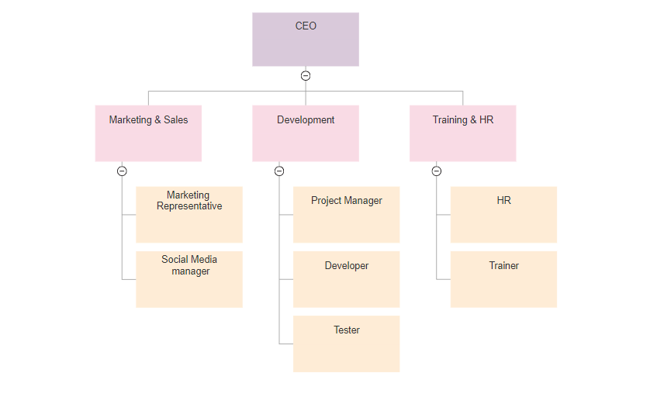Different posts in Dk Techno’s.**

* + CEO.
  + Marketing Representative.
  + Project Manager.
  + Developer.
  + Tester.
  + HR.
  + Trainer.

**Study of responsibilities of different posts in Dk Techno’s.**

1) CEO:

* Plan, develop, implement and direct the organization’s operational and fiscal function and performance.
* Act as a strategic partner by developing and implementing the company’s plans and programs.
* Analyze and make recommendation on the impact of long range growth initiatives, planning, and introduction of new strategies and regulatory actions.
* Develop credibility and authority for the finance leadership team by providing accurate analysis of budgets, reports and financial trends and operational procedures in order to assist the BOD and senior executive team.
* Create, improve, implement and enforce policies and procedures of the organization that will improve operational and financial effectiveness of the company.

2) Marketing Representative:

* Selling products and services using solid arguments to prospective customers.
* Performing cost-benefit analyses of existing and potential customers.
* Maintaining positive business relationships to ensure future sales.

3) Social Media Manager:

* Work closely with the marketing team to develop social media campaigns that help to achieve corporate marketing goals
* Develop monthly reports on emerging social media trends that will be submitted to the management and executive teams
* Monitor the company’s social media accounts and offer constructive interaction with users
* Create methods for finding and saving online customer reviews

5) Analyze the long-term needs of the company’s social media strategy and offer quarterly reports to the management and executive teams that outline any necessary changes to the digital marketing plan.

4) Project Manager:

Software project managers are in charge of the planning, scheduling, budgeting, execution, and delivery of software and web projects. They ensure the successful completion of all software projects and also oversee the people performing work on the projects.

5) Developer:

Researching, designing, implementing, and managing software programs. Testing and evaluating new programs. Identifying areas for modification in existing programs and subsequently developing these modifications. Writing and implementing efficient code.

6) Tester:

Software Testers are responsible for the quality of software development and deployment. They are involved in performing automated and manual tests to ensure the software created by developers is fit for purpose. Some of the duties include analysis of software, and systems, mitigate risk and prevent software issues.

7) HR: HR (human resources) is an organization's department responsible for hiring, training and maintaining employees. These professionals create policies and ensure employees are satisfied with their job. In a small software company, HR plays a key role in the recruitment of highly qualified software professionals.

8) Trainer: A software trainer trains and motivates individuals and groups to adopt a new computer application or program on the behalf of a company that has created the software or for one that is introducing it for use by its staff.

**#4**

**Laboratories**

**1) Software Validation Test Lab**

A software’s user experience can have direct impact on consumer satisfaction. Allion’s software validation program validates software functionalities based on industry ecosystem and the system device’s attributes; to ensure the software program’s application and usability are close to actual user requirements.

**The Importance of Software Testing**

Smoothness and usability of software operation can directly affect consumers’ satisfaction. In response to the increasing diversity of the design of software and user interface, Allion’s software validation will base on the different industry ecosystem and system device’s attributes, to help our consumers find out software issues and validate the software’s interoperability, stability, security, and functionality, assuring our consumers that their product’s software applications and usability meet users expectations.

**Computer Hardware Lab**

Computer hardware lab helps students to gain knowledge regarding system hardware. Students can also practice their hands-on hardware and troubleshooting experiments.

**2) Hardware Details:**

Computer System – 5,

1. **1**. Make: HP,

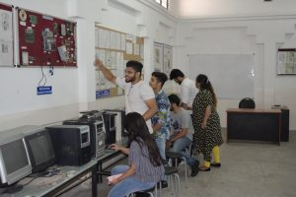

Model: DX6120MT,

HDD:500 GB,

RAM: 4 GB,

Processor-2.80GHz.

1. Make: HP,

Model: DX6120MT,

HDD: 500 GB,

RAM: 8 MB,

Processor – 2.80GHz.

1. Make: HP,

Model: D290MT,

HDD: 500GB,

RAM: 8 GB,

Processor- 2.66GHz

**Software Details:** Windows Operating System.

**#5**

**Core Techs for Software**

* **Front end Technologies used by Company.(Mainly used )**

1. **HTML.**

HTML stands for Hypertext Markup Language. It is used to design web pages using a markup language. HTML is the combination of Hypertext and Markup language. Hypertext defines the link between the web pages. A markup language is used to define the text document within tag which defines the structure of web pages. This language is used to annotate (make notes for the computer) text so that a machine can understand it and manipulate text accordingly. Most markup languages (e.g. HTML) are human-readable. The language uses tags to define what manipulation has to be done on the text.

HTML is a markup language used by the browser to manipulate text, images, and other content, in order to display it in the required format. HTML was created by Tim Berners-Lee in 1991. The first-ever version of HTML was HTML 1.0, but the first standard version was HTML 2.0, published in 1999.

1. **CSS.**

Cascading Style Sheets, fondly referred to as CSS, is a simply designed language intended to simplify the process of making web pages presentable. CSS allows you to apply styles to web pages. More importantly, CSS enables you to do this independent of the HTML that makes up each web page.

CSS is easy to learn and understood, but it provides powerful control over the presentation of an HTML document.

1. **JavaScript.**

JavaScript is a lightweight, cross-platform, and interpreted scripting language. It is well-known for the development of web pages, many non-browser environments also use it. JavaScript can be used for Client-side developments as well as Server-side developments. JavaScript contains a standard library of objects, like Array, Date, and Math, and a core set of language elements like operators, control structures, and statements.

& All frameworks of JavaScript as per need of project.

This are the Front end technologies used by DK. Techno’s for Developing UI of various software applications.

* **Backend technologies used by Industry.**

1. **JAVA:**

JAVA was developed by James Gosling at Sun Microsystems Inc in the year 1991, later acquired by Oracle Corporation. It is a simple programming language. Java makes writing, compiling, and debugging programming easy. It helps to create reusable code and modular programs.

Java used by DK Techno’s to develop various High scale Internet Applications & develop Android applications.

1. **PHP:**

The term PHP is an acronym for PHP: Hypertext Preprocessor. PHP is a server-side scripting language designed specifically for web development. It is open-source which means it is free to download and use. It is very simple to learn and use. The files have the extension “.php”. Rasmus Lerdorf inspired the first version of PHP and participating in the later versions. It is an interpreted language and it does not require a compiler.

PHP is used by DK Techno’s to develop low budget small scale applications.

**3) Python:**

Python is a general-purpose programming language that is becoming ever more popular for data science. Companies worldwide are using Python to harvest insights from their data and gain a competitive edge. Unlike other Python tutorials, this course focuses on Python specifically for data science. In our Introduction to Python course, you’ll learn about powerful ways to store and manipulate data, and helpful data science tools to begin conducting your own analyses.

DK Techno’s is using python for various Data Analysis projects.

* **Database technologies used by DK Techno’s.**

**1) SQL Server:**

Data is a collection of facts and figures and we have humungous data available to the users via the internet and other sources. To manipulate the data, [Structured Query Language (SQL)](https://www.geeksforgeeks.org/structured-query-language/) in short has been introduced years ago. There are different versions of SQL available in the market provided by different organizations. In this article, we shall see the version of SQL provided by Microsoft.

**Introduction :**

1. Microsoft SQL Server or MS SQL Server for short is the query language provided for data definition and manipulation.
2. SQL Server is a Relational Database Management Systems which was developed and marketed by the Microsoft company.
3. SQL and SQL servers are built as two layers where the SQL server is on the top for interacting with the relational databases.
4. MS SQL Server also has T-SQL or Transact-SQL and the main focus of T-SQL is to handle the transactions.
5. As it is a Microsoft’s developed system, it worked only on Microsoft’s environment until it was made available on Linux platforms in the year 2016.

**2) Oracle:**

Oracle database is a relational database management system (RDBMS) from Oracle Corporation. This article will explain a complete overview of the Oracle database, features, history, and editions. Before discussing the oracle, we will first need to know about the database.

Oracle database is a relational database management system. It is also called **OracleDB**, or simply **Oracle**. It is produced and marketed by **Oracle Corporation**. It was created in **1977** by **Lawrence Ellison** and other engineers. It is one of the most popular relational database engines in the IT market for storing, organizing, and retrieving data.

Oracle database was the first DB that designed for **enterprise grid computing** and data warehousing. Enterprise grid computing provides the most flexible and cost-effective way to manage information and applications. It uses SQL queries as a language for interacting with the database.

**Editions of Oracle database**

Oracle database is compatible with a wide range of platforms such as Windows, UNIX, Linux, and macOS. It supports several operating systems like IBM AIX, HP-UX, Linux, Microsoft Windows Server, Solaris, SunOS, macOS, etc. In the late **1990s**, Oracle began supporting open platforms like GNU/Linux.

**The following is a list of Oracle database editions in order of priority:**

* **Enterprise Edition:** It is the most robust and secure edition. It offers all features, including superior performance and security.
* **Standard Edition:** It provides the base functionality for users that do not require Enterprise Edition's robust package.
* **Express Edition (XE):** It is the lightweight, free and limited Windows, and Linux edition.
* **Oracle Lite:** It is designed for mobile devices.
* **Personal Edition:** It's comparable to the Enterprise Edition but without the Oracle Real Application Clusters feature.
* **Different IDE’s used by DK Techno’s.**

An integrated development environment (IDE) is a software application that provides comprehensive facilities to computer programmers for software development. An IDE normally consists of at least a source code editor, build automation tools and a debugger

**1) Android Studio**

Android Studio is an IDE for Google Android Development launched on 16th May 2013, during Google's I/O 2013 event. Android Studio contains all the Android tools to design, test, debug, and profile your application. The Android Studio uses Gradle to manage your project, a Build Automation Tool.

Android Development at DK Techno’s is Done in Android Studio.

**2) Visual Studio.**

Visual Studio is an Integrated Development Environment (IDE) developed by Microsoft to develop GUI (Graphical User Interface), console, Web applications, web apps, mobile apps, cloud, and web services, etc. With the help of this IDE, you can create managed code as well as native code.

Visual studio is used to develop various Desktop applications at DK Techno’s.

**3) Eclipse.**

Eclipse is an integrated development environment (IDE) that takes care of compiling and running Java programs in addition to providing other useful features such as version control and debugging. Thus, it is a popular tool for programmers to write and test their code.

Eclipse is used for development of applications using JAVA.

* **Hosting services used by DK Techno’s.**

A web hosting means “hosting your website” on the Internet whereas a web hosting service is a service which provides space for you to host your website on the internet. If you develop a site and intend to publish it, hosting it becomes a prerequisite.

**Various web hosting services by DK Techno’s are:**

* GoDaddy.
* Hostinger.
* Cloud ways.
* HostGator.
* Host winds.
* Bluehost.

Hosting Plan & Service choosing is done as per the project requirements and the budget of client.

* **Domain Services used by DK Techno’s.**

A domain name is an identification string that defines a realm of administrative autonomy, authority or control within the Internet. Domain names are used in various networking contexts and for application-specific naming and addressing purposes. In general, a domain name identifies a network domain, or it represents an Internet Protocol (IP) resource, such as a personal computer used to access the Internet, a server computer hosting a website, or the web site itself or any other service communicated via the Internet. In 2017, 330.6 million domain names had been registered.

**Various Domain register services by DK Techno’s are:**

* Domain.com.
* GoDaddy.com.
* Namecheap.com.
* Name.com.
* Google Domains.
* Enom.com.
* Dynadot.com.
* NameSilo.com.

Domain register service provides has been selected as per the availability of Domain Name & It’s Cost.

**#6**

**Software Development**

***Requirement Analysis Process.***

Requirement analysis is significant and essential activity after elicitation. We analyze, refine, and scrutinize the gathered requirements to make consistent and unambiguous requirements. This activity reviews all requirements and may provide a graphical view of the entire system. After the completion of the analysis, it is expected that the understandability of the project may improve significantly. Here, we may also use the interaction with the customer to clarify points of confusion and to understand which requirements are more important than others.

***Design Process.***

The design phase of software development deals with transforming the customer requirements as described in the SRS documents into a form implementable using a programming language.

The software design process can be divided into the following three levels of phases of design:

Interface Design

Architectural Design

Detailed Design

***Development Process.***

In software engineering, a software development process is the process of dividing software development work into smaller, parallel or sequential steps or subprocesses to improve design, product management, and project management. It is also known as a software development life cycle (SDLC). The methodology may include the pre-definition of specific deliverables and artifacts that are created and completed by a project team to develop or maintain an application

**#7**

**Security Practices**

1. Patch your software and systems

Many attackers exploit known vulnerabilities associated with old or out-of-date software. To thwart common attacks, ensure that all your systems have up-to-date patches. Regular patching is one of the most effective software security practices.

Of course, you can’t keep your software up to date if you don’t know what you’re using. Today, an average of 70%—and often more than 90%—of the software components in applications are open source. You need to maintain an inventory, or a software bill of materials (BOM), of those components. A BOM helps you make sure you are meeting the licensing obligations of those components and staying on top of patches.

It’s challenging to create a software BOM manually, but a software composition analysis (SCA) tool will automate the task and highlight both security and licensing risks.

2. Educate and train users

[](https://www.synopsys.com/blogs/software-security/wp-content/uploads/2020/06/top-10-software-security-best-practices-2.jpg)

Employee training should be a part of your organization’s security DNA. Having a well-organized and well-maintained security training curriculum for your employees will go a long way in protecting your data and assets. Include awareness training for all employees and secure coding training for developers. Do it regularly, not just once a year. And conduct simulations like phishing tests to help employees spot and shut down social engineering attacks.

3. Automate routine tasks

Attackers use automation to detect open ports, security misconfigurations, and so on. So you can’t defend your systems using only manual techniques. Instead, automate day-to-day security tasks, such as analyzing firewall changes and device security configurations. Automating frequent tasks allows your security staff to focus on more strategic security initiatives.

You can also automate much of your software testing if you have the right tools. That includes, as noted in No. 1, maintaining a software BOM to help you update open source software components and comply with their licenses. With an SCA tool, you can automate a task that you simply can’t do manually.

4. Enforce least privilege

Ensure that users and systems have the minimum access privileges required to perform their job functions. Enforcing the principle of least privilege significantly reduces your attack surface by eliminating unnecessary access rights, which can cause a variety of compromises.

[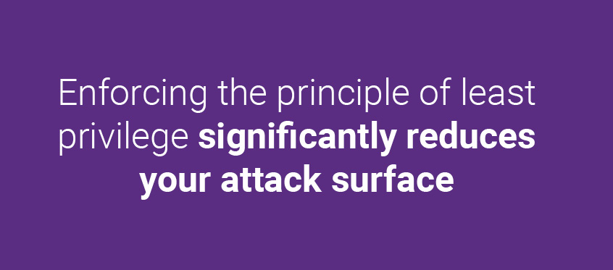](https://www.synopsys.com/blogs/software-security/wp-content/uploads/2020/06/top-10-software-security-best-practices-3.jpg)

That includes avoiding “privilege creep,” which happens when administrators don’t revoke access to systems or resources an employee no longer needs. Privilege creep can occur when an employee moves to a new role, adopts new processes, leaves the organization, or should have received only temporary or lower-level access in the first place.

5. Create a robust IR plan

No matter how much you adhere to software security best practices, you’ll always face the possibility of a breach. But if you prepare, you can stop attackers from achieving their mission even if they do breach your systems. Have a solid incident response (IR) plan in place to detect an attack and then limit the damage from it.

[](https://www.synopsys.com/blogs/software-security/wp-content/uploads/2020/06/top-10-software-security-best-practices-4.jpg)

6. Document your security policies

Maintain a knowledge repository that includes comprehensively documented software security policies. Security policies allow your employees, including network administrators, security staff, and so on, to understand what activities you’re performing and why.

Also, it’s not enough just to have policies. Make sure everybody reads them. At a minimum, make that part of the onboarding process for new employees.

[](https://www.synopsys.com/blogs/software-security/wp-content/uploads/2020/06/top-10-software-security-best-practices-5.jpg)

7. Segment your network

Segment your network is an application of the principle of least privilege. Proper network segmentation limits the movement of attackers. Identify where your critical data is stored, and use appropriate security controls to limit the traffic to and from those network segments.

8. Integrate security into your SDLC

Integrate software security activities into your organization’s software development life cycle (SDLC) from start to finish. Those activities should include architecture risk analysis, static, dynamic, and interactive application security testing, SCA, and pen testing. Building security into your SDLC does require time and effort at first. But fixing vulnerabilities early in the SDLC is vastly cheaper and much faster than waiting until the end. Ultimately, it reduces your exposure to security risks.

9. Monitor user activity

[](https://www.synopsys.com/blogs/software-security/wp-content/uploads/2020/06/top-10-software-security-best-practices-6.jpg)

Trust, but verify. Monitoring user activities helps you ensure that users are following software security best practices. It also allows you to detect suspicious activities, such as privilege abuse and user impersonation.

10. Measure

Define key metrics that are meaningful and relevant to your organization. Well-defined metrics will help you assess your security posture over time.

[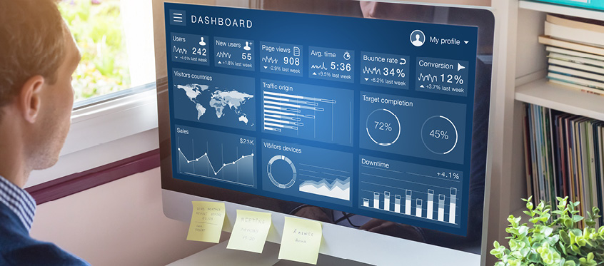](https://www.synopsys.com/blogs/software-security/wp-content/uploads/2020/06/top-10-software-security-best-practices-7.jpg)

Best practices for better software security

There’s no silver bullet when it comes to securing your organization’s assets. But you can make your organization a much more difficult target by sticking to the fundamentals. Following these top 10 software security best practices will help you cover those fundamentals. When you’re ready, take your organization to the next level by starting a software security program.

**#8**

**Testing & Quality Assurance**

***Testing Process.***

Step-1: Assess Development Plan and Status – ...

Step-2: Develop the Test Plan – ...

Step-3: Test Software Requirements – ...

Step-4: Test Software Design – ...

Step-5: Build Phase Testing – ...

Step-6: Execute and Record Result – ...

Step-7: Acceptance Test – ...

Step-8: Report Test Results –

***Quality Assurance.***

Software quality management (SQM) is a management process that aims to develop and manage the quality of software in such a way so as to best ensure that the product meets the quality standards expected by the customer while also meeting any necessary regulatory and developer requirements, if any.Software quality managers require software to be tested before it is released to the market, and they do this using a cyclical process-based quality assessment in order to reveal and fix bugs before release. Their job is not only to ensure their software is in good shape for the consumer but also to encourage a culture of quality throughout the enterprise.

***Supporting Applications.***

The Software Support Procedure ensures that customers can effectively install and operate the software they purchase from your company. The Software Support Procedure also provides help for customers who have questions about or problems with the software they purchase from your company.

**#9**

**Customer Lobby**

* Recent Developed projects of Dk Techno’s.

**1) Inventory Software**

**Very easy Billing software. Useful for**Wholesale, Retail, Agency, Super Bazar, Garment Shop And All Other Shops**With following features**

* GST
* SMS
* Sale-Purchase
* Credit-Debit Accounting
* Expenses
* Return
* Barcode

2) **Sand Sale Management**

Very easy Billing software. Useful for **Sand Seller, Stone Crusher, etc.** With following features

* Driver Management
* SMS
* Sale Management
* Vehicle Expense
* Petrol Pump Accounting
* Accounting
* Trip Commission

3) **Online Hotel Management**

Very easy Billing software. Useful for **Hotel/Restaurant** With following features

* Online Order Booking
* Online Table Reservation
* Total Inventory
* Counter & Kitchen Screen
* POS System
* Accounting
* All other features

4) **Audit Software**

Very easy Audit software. Useful for **Auditor/CA, etc.**  With following features

* Day Book Entry
* **Terij, Taleband, Nafa-Tota, Vyapar Patrak Reports**
* Multiple Clients Option
* **Kird,Babwar Report**
* More Feature

5) **Employee Society Software**

Very easy Audit software. Useful for **Employee Society** With following features

* Day Book Entry
* **Terij, Taleband, Nafa-Tota, Vyapar Patrak Reports**
* Multiple Clients Option
* **Kird, Babwar Report**
* Loan Management
* Debit Reports
* NPA Reports
* All features

6) **Online / Offline School Software**

Very easy Audit software. Useful for **Schools and Institutes**With following features

* Student Management
* **Accounting**
* Hostel Library, Teachers Modules
* **Online Exam, Marksheet, Reports System with SMS and Web Dashboard**
* More Features.

7) **Stitching Software**

Very easy Audit software. Useful for **Tailors**With following features

* Customer Management
* **Measure Management**
* Work Slip Print
* **Work Assign Management**
* More Features

1) News & Information Portals.

* Shetkaritimes.com



* Shetimitra.co.in



* Thepostmortem.live



* Yesnewsmarathi.com



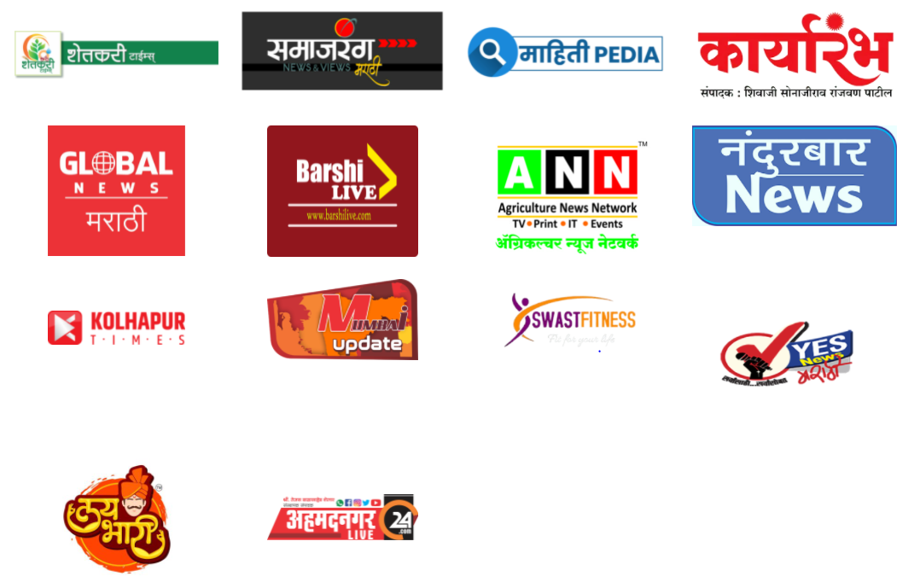

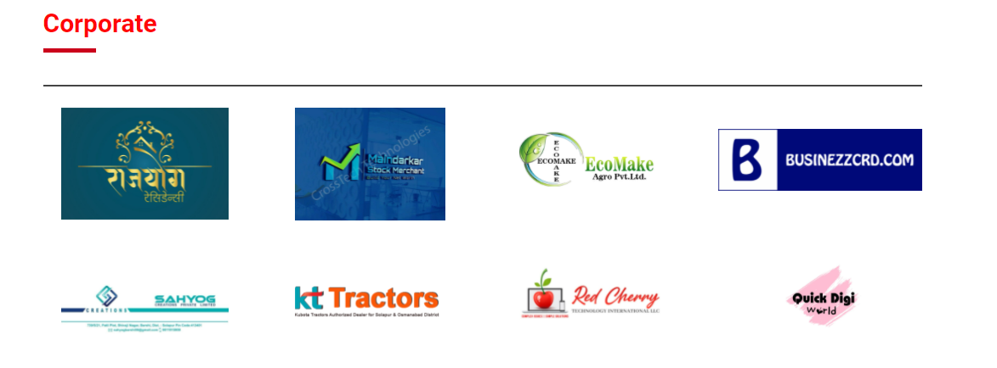

**#10**

**My 45 Days**

Training is a learning experience in that it seeks a relatively permanent change in an individual that will improve his or her ability to perform on the job Training can involve the changing of skills, knowledge, attitudes or behavior. It may mean changing what employees know, how they work, their attitudes towards their work, or their interaction with their co-workers or supervisors.

Employee development, by design, is more future-oriented and more concerned with education than employee training. Education means that the employee development activities attempt to instill sound reasoning processes – to enhance one’s ability to understand and interpret knowledge-rather than imparting a body of facts or teaching a specific set of motor skills. Development, therefore, focuses more on the employee’s personal growth.

Successful employees prepared for positions of greater responsibility, have analytical, human, conceptual and specialized skills. They are able to think and understand Training per se, cannot overcome an individual’s inability to understand cause-and-effect relations, to synthesize from experience, to visualize relationships, or to think logically.

As a result, I suggest that employee development be predominantly an education process rather than a training process.

Finally I have really great experience of 45 Days Industrial Training at Dk. Techno’s Solapur.

**#11**

**Project**

**Study Material Application**

**PART A – Micro-Project Proposal**

**LEARNING MANAGEMENT SYSTEM**

1. **Brief Introduction:**

Study Mate is an innovative and user-friendly application developed in flutter tailored specifically to cater to the needs of diploma engineering students. Study mate is not just a just a study tool; it’s a virtual mentor guiding you through your diploma education and helping you to achieve your academic goals.

**2.0 Aim of the Micro-Project:**

This Micro-Project aims at:

**•** Developing Study Material Application.

• Providing all necessary study material for achieving academic goals.

**3.0 Intended Course Outcomes:**

* Develop programs using Dart programming language and implement in Flutter.
* Apply Software Development Lifecycle.
* Develop Hybrid Applications using Flutter.
* Software Testing.
* Following Software Development Ethics.

**4.0 Literature Review:**

For this micro project we took help of teachers and internet. We run the project program on Android. And collected the information from various books and many websites.

**4.0 Proposed Methodology:**

1. To decide the topic name of the project.
2. To search the information about project.
3. Collect all materials to complete the project.
4. To create the report for the microproject.
5. To start presenting the project.

**5.0 Resources Required** (major resources like raw material, tools, software etc.)

|  |  |  |  |
| --- | --- | --- | --- |
| **S. No.** | **Name of Resource/material** | **Specifications** | **Qty** |
|  | Computer system | 4 GB ram,64bit | 1 |
|  | Software | Android | 1 |
|  | Chrome | - | 1 |

**6.0 Action Plan** (Sequence and time required for major activities for 8 Weeks)

|  |  |  |  |  |
| --- | --- | --- | --- | --- |
| **S. No.** | **Details of activity** | **Planned Start date** | **Planned Finish date** | **Name of Responsible Team Members** |
|  | **To decide the topic of the project**. | 30-05-2021 | 30-05-2021 | All Members |
|  | **Collect all resources to creating project.** | 31-05-2021 | 31-05-2021 | Abhishek Maske, Kaustubh Makude |
|  | **Take guidance from teachers. And perform the coding then** | 01-06-2021 | 02-06-2021 | Dharashivkar Aditya, Tanmay Kulkarni, Shriyash Sawalgi |
|  | **Preparing and presenting the project.** | 04-06-2021 | 05-06-2021 | All Members |

**\*\*\*\*\*\*\*\*\*\*\*\*\*\***

**PART B – Micro-Project Report**

**LEARNING MANAGEMENT SYSTEM**

1. **Rationale**

Study Mate is an innovative and user-friendly application developed in flutter tailored specifically to cater to the needs of diploma engineering students. Study mate is not just a just a study tool; it’s a virtual mentor guiding you through your diploma education and helping you to achieve your academic goals.

1. **Course Outcomes Addressed:**

* Develop programs using Dart programming language and implement in Flutter.
* Apply Software Development Lifecycle.
* Develop Hybrid Applications using Flutter.
* Software Testing.
* Following Software Development Ethics.

**3.0 Literature Review:**

For this micro project we took help of teachers and internet. We run the project program on Android. And collected the information from various books and many websites.

**4.0 Actual Methodology Followed:**

1. To search the topics and collect the information related project.

2. To learn the syllabus about project.

3. To conversation between teachers and friends.

4. To create a word document of project.

5. To preparation and presenting the project.

**5.0 Actual Resources Used (**Mention the actual resources used)**.**

|  |  |  |  |
| --- | --- | --- | --- |
| **S. No.** | **Name of Resource/material** | **Specifications** | **Qty** |
|  | Computer system | 4 GB RAM,64 storage | 1 |
|  | Android | 4 GB RAM,64 storage | 1 |
|  | Laptop | 4 GB RAM,64 storage | 1 |

**6.0** **Skill Developed / learning out of this Micro-Project**

1. Communication skill.
2. Presentation skill is developed.
3. How to make a project. This skill is learnt throughout the micro project.
4. Technical knowledge is developed.

**7.0 Applications of this Micro-Project:**

* **Providing Study and Curriculum related material for Diploma IT students**

**8.0 Area of Future Improvement**

* **Providing Study and Curriculum related material for Diploma all students**

**Output**

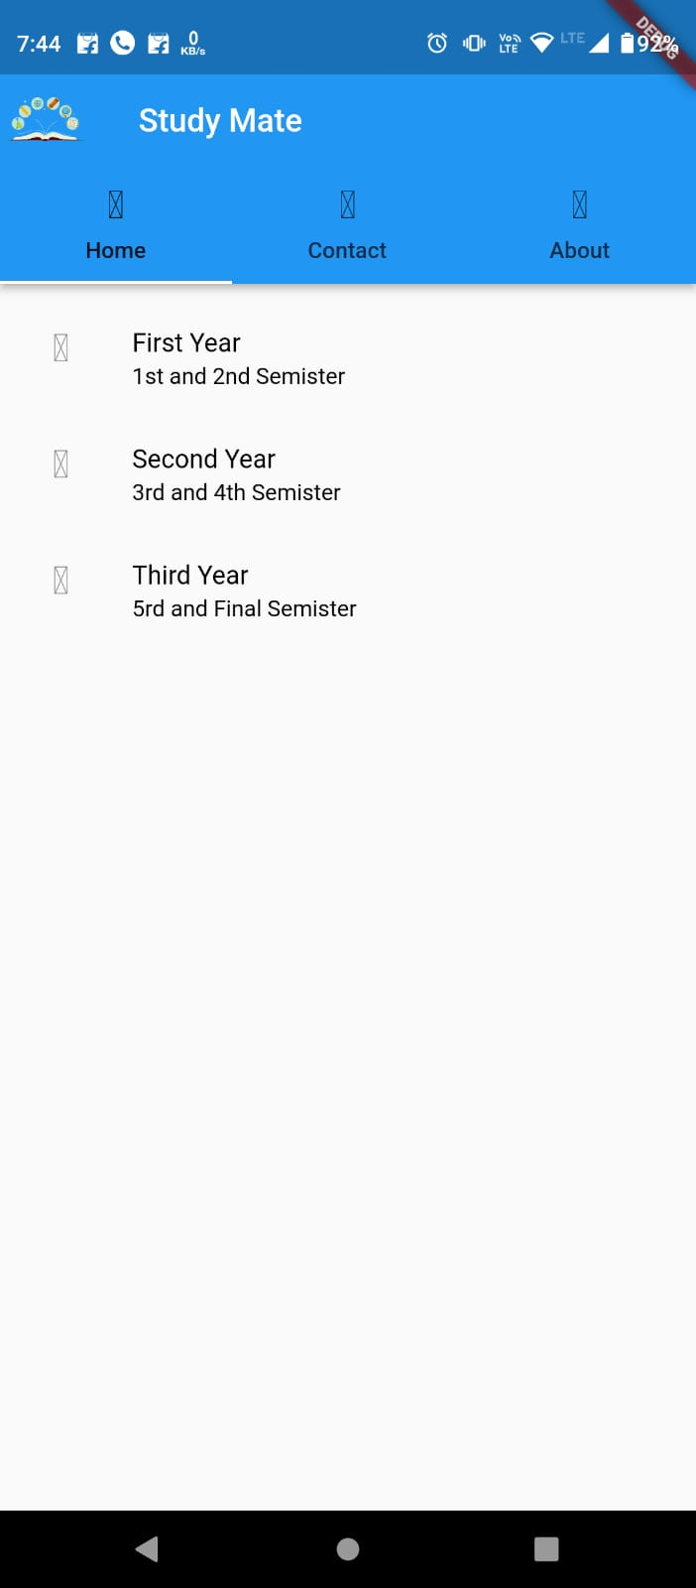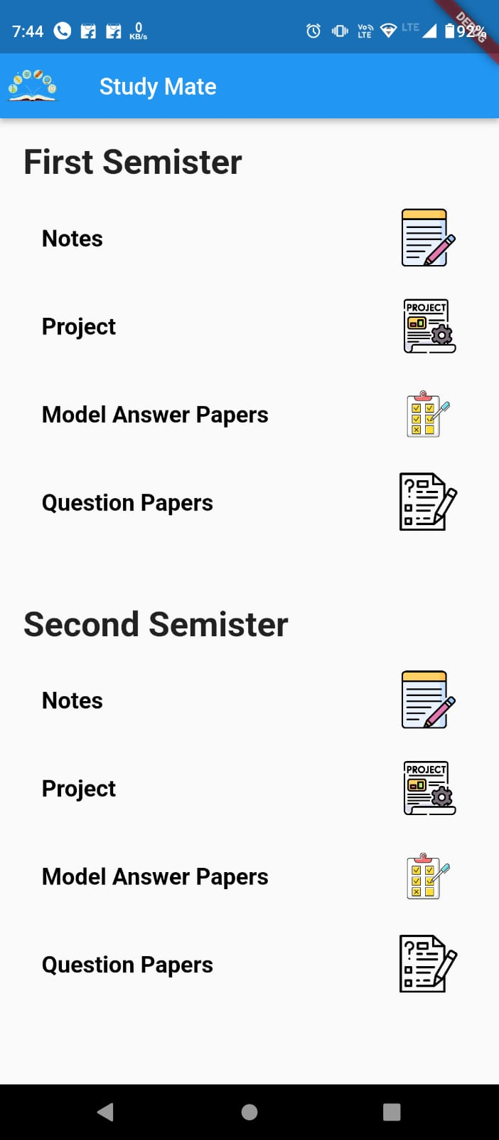

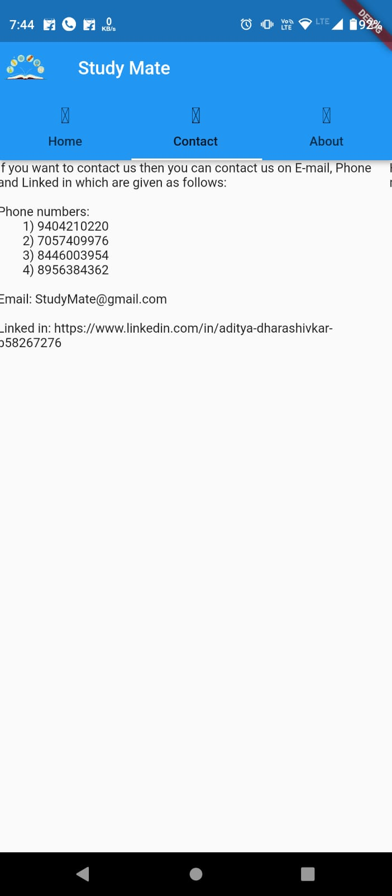

**Micro-Project Evaluation Sheet**

|  |  |  |  |  |
| --- | --- | --- | --- | --- |
| **Process Assessment** | | **Product Assessment** | | **Total Marks**  **10** |
| **Part A -  Project Proposal**  **(2 marks)** | **Project Methodology**  **(2 marks)** | **Part B - Project Report/Working Model**  **(2 marks)** | **Individual Presentation/ VIVA (4 marks)** |
|  |  |  |  |  |

**Note:**

Every course teacher is expected to assign marks for group evolution for each group of students in first 3 columns as per rubrics & individual evaluation in 4TH column for each group of students as per rubrics based on viva.

**Comments/Suggestions about team work/leadership/inter-personal communication (if any)**

………………………………………………………………………………………………

 ……………………………………………………………………………………………..

……………………………………………………………………………………………..

……………………………………………………………………………………………..

**Any Other Comment:**

……………………………………………………………………………………………

 ……………………………………………………………………………………………

……………………………………………………………………………………………

………………………………………………………………………………………………

**Name and designation of the Faculty Member…………………………………….**

**Signature………………………………………………………………………………**

**#12**

**References.**

1) [www.dktechs.in](http://www.dktechs.in)

2) Software testing Manual.

3) <https://www.linkedin.com/pulse/what-makes-software-solution-market-standard-alan-gulino>

4) <https://www.historyofinformation.com/detail.php?id=935>

5) <https://recruitinginnovation.com/blog/front-end-technologies/#:~:text=These%20three%20main%20front%2Dend,we%20interact%20with%20every%20day.&text=HTML%20is%20the%20first%20layer,a%20wireframe%20on%20a%20webpage>.

6) <https://www.tutorialspoint.com/sdlc/sdlc_overview.htm>

7) <https://stackify.com/what-is-sdlc/>

8) <https://www.softwaretestinghelp.com/software-development-life-cycle-sdlc/>